Maggie Andrews Darkscapes (Raku ware)
Raku ware (楽焼 raku-yaki?) is a type of Japanese pottery that is traditionally used in the Japanese Tea Ceremony, most often in the form of tea bowls. It is traditionally characterised by being hand shaped rather than thrown; fairly porous vessels, which result from low firing temperatures and the removal of pieces from the kiln while still glowing hot. In the traditional Japanese process, the fired raku piece is removed from the hot kiln and is allowed to cool in the open air. The familiar technique of placing the ware in a container filled with combustible material, is not a traditional Raku practice.
The use of Porcelain clay in the construction of the vessels enables Maggie to retain the intricate characteristics of her high fired porcelain whilst enabling the intrinsic qualities of Raku can bring to her work. The effects of the reduction process allows Maggie to portray qualities of landscape of a more primeval vista.
.

Oxidation /Reduction

In the western style of Raku firing, the metal container acts as a reduction chamber, which is a container that allows the carbon dioxide to pass through a small hole. A reduction atmosphere is created by closing the container.] A reduction atmosphere induces a reaction between oxygen and the clay minerals, which creates the colour of the glaze It also affects the metal elements of the glaze The reaction uses oxygen from the atmosphere within the reduction tube, and, to continue, it receives the rest of the oxygen from the glaze. This creates iridescent lustre and metallic qualities. This creates a metallic effect. Pieces with no glaze have nowhere to get the oxygen from, so they take it from clay minerals. This atmosphere will turn clay black, making a matte colour.

Firing Process

1Kiln is loaded with bisque vessels and fired up to temperature.

2 During the firing the combustible bins are filled with sawdust.

3 The firing chamber is lifted away revealing the glowing vessels

4 With metal tongs they are taken from the firing platform and place individually in the bins

5 The sawdust ignites and a lid is then placed over the bin to create the reducing atmosphere

6 The vessels are left to cool and then placed in water and excess sawdust removed.

. 1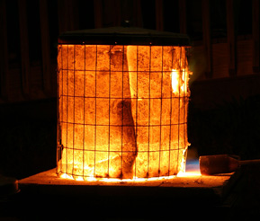 2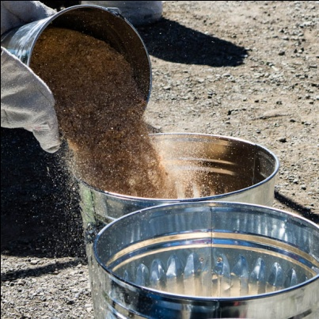 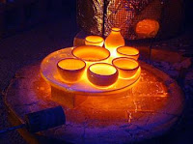 3 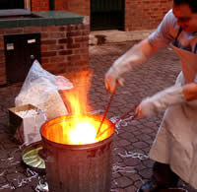4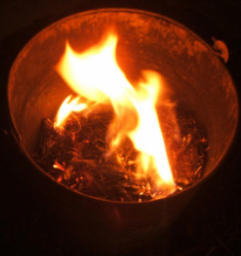5 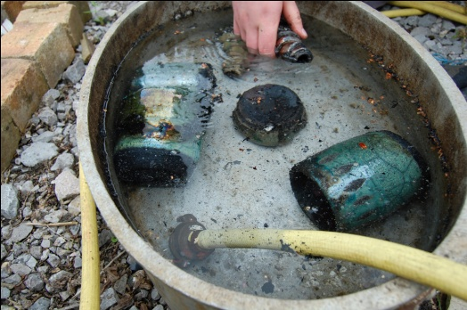6
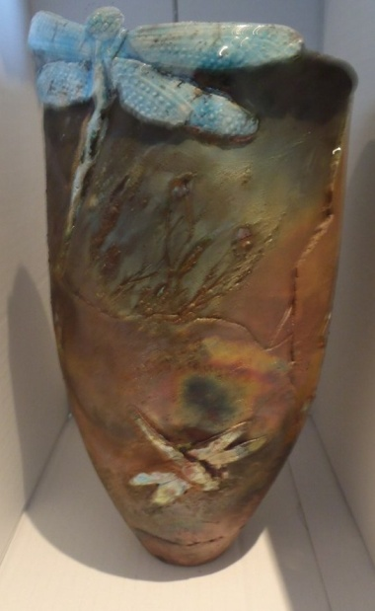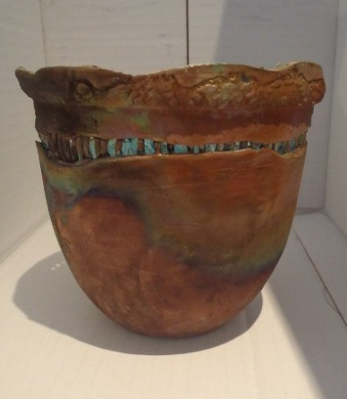 Completed vessels

